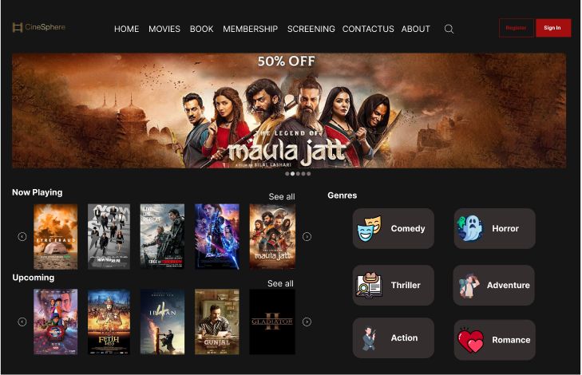

|  |
| --- |
| CWC Project  Cinema Web |
|  |
| Usman Ali  Basil Ali  Rohma Talal  Malik Abdul Haseeb |

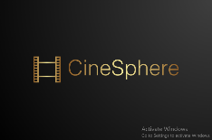

# Details and working

|  |
| --- |
| Design:  This website is totally designed by Usman Ali (Visually on Figma).  Code:  The code is developed by all members of the group, each member worked on different pages that he or she was assigned.  Comments:  Comments are added by members as well as chatgpt is used to add comments to reduce effort on unrelated things.  Images and Icons:  Images and icons are downloaded from FlatIcon website, mostly 3rd party donated icon from freepik.  JavaScript:  To perform some actions we added JavaScript from different sources but added the function that we understand.  Bootstrap:  To fulfill the requirement of adding bootstrap, we learned it from the playlist provided by you and added it in most of the pages.  Colors:  Colors of website are selected very carefully after getting review from fellow students, chatgpt and khroma.co, behind color selection color selection theory was involved as well. Project is described below: First submission:  In first submission page distribution is as following:   * Usman Ali – Home Page + Header + Footer * Basil Ali – About Page * Rohma – Special Screening Page * Haseeb & Usman – Loyalty card and Membership Page |
| Second submission:  In first submission page distribution is as following:   * Usman Ali – Q&A + T&C + About Us * Basil Ali – Playing Now + Genre pages * Rohma – Confirmation + Movie pages * Haseeb & Usman – Ticket booking + Seat Selection   **Remarks for submission:**  This website was our first project and we put our maximum effort even one of our members spent 78 hours (8, 12 hours of constative working for one page). We hope that you will like this website, we have used minimalistic dark theme and design and made it very clear so there is no UX problem.  **----------** |